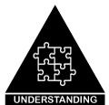
Cognitive Verb Progression: Describe
Describe: To give a detailed account of the properties, qualities, features or parts of something or someone. (Thinkdrive 2019)
Related Key Words: Depict, narrate, outline, recount, re-tell, relate, state, summarise, tell
Graphic Organisers: Attribute Listing Matrix, Mind-map, Y-chart

DESCRIBE: oral or written
Step 6 | I can create a detailed description of a person, experience or thing and communicate it effectively
Step 5 | I can create a sound description of a person, experience or thing
Step 4 | I can add relevant details to the structure
Step 3 | I can connect the main parts in a meaningful manner (a way that makes sense to me)
Step 2 | I can recognise its parts
Step 1 | I can remember something that I wish to describe
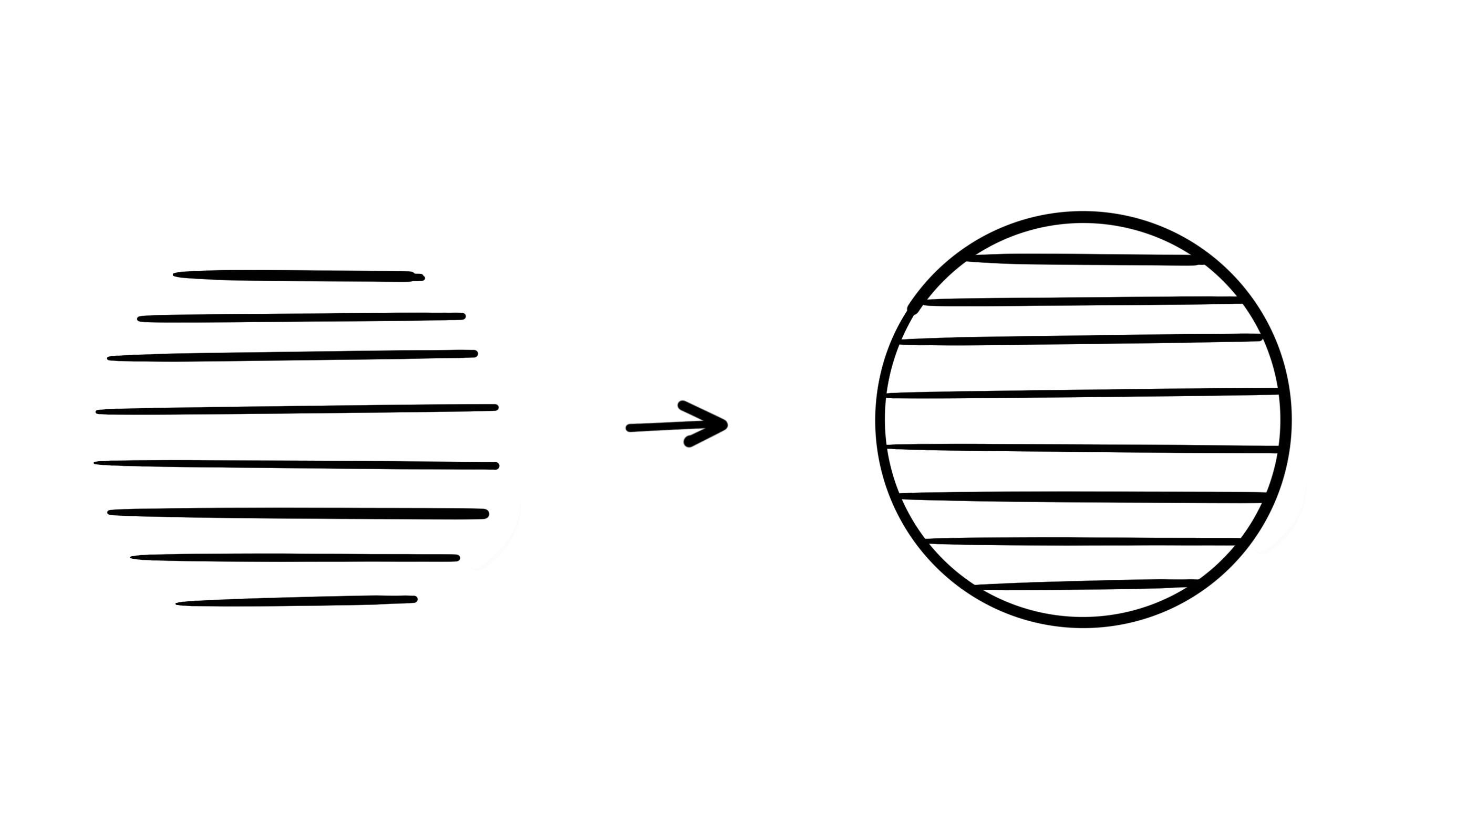

References:
Claxton, G. (2011). The Learning Powered School, UK: TLO Limited
Summit Learning and the Stanford Centre for Assessment, Learning & Equity, SCALE, (May 2017). The Summit Cognitive Skills Rubric, CA.
https://cdn.summitlearning.org/assets/marketing/Cognitive-Skills-Document-Suite.pdf
Thinkdrive (2019). ITC Publications. thinkdrive@itcpublications.com.au
Heritage College 2019, J. Farrall, AISSA & A. Pegler, Dara School, 2020

