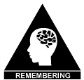
Learning Progression Cognitive Verbs: Identify
Identify: When we identify something, we recognise or tell what something is. (Heskett, Book 2, 2019)
If you can identify someone or something:
- you are able to recognise them or distinguish them from others.
- you name them or say who or what they are
- you feel that you understand them or their feelings or ideas (QCAA 2018)

If you identify something, you discover or notice its existence.

Related Key Words: define, distinguish, locate, name, recognise, select
Graphic Organisers: KWHL
Identify
4 | I can communicate my finding.
3 | I can use those features to single out what I am looking for.
2 | I can recognise the important features of what I want to identify
1 | I can work out what needs to be identified
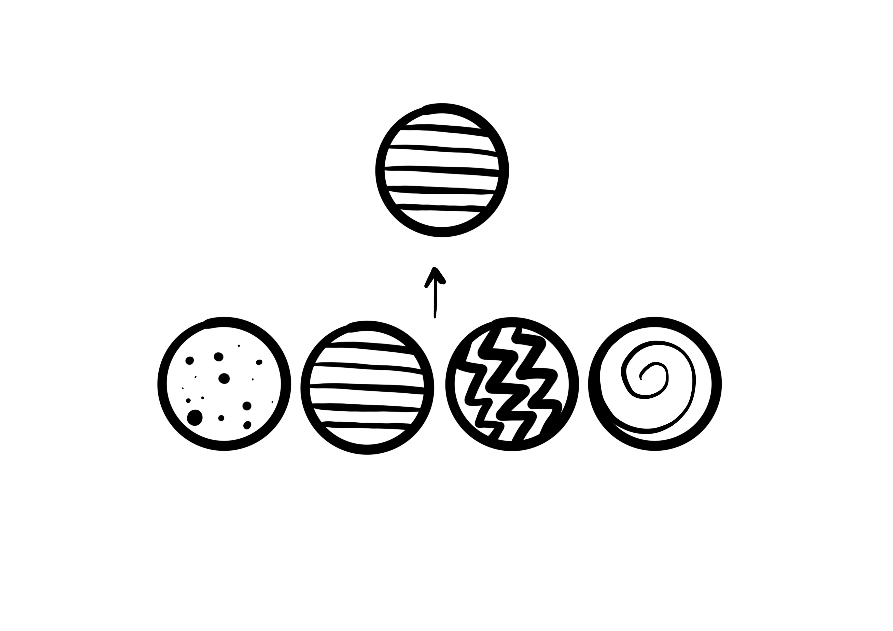

References:
Heskett, T. (2019). Mastering academic vocabulary, Book 2. Melbourne: Hawker Brownlow Education
Queensland Curriculum &Assessment Authority. QCAA. (2018). Glossary of Cognitive Verbs. https://www.qcaa.qld.edu.au/downloads/portal/snr_glossary_cognitive_verbs.pdf
Queensland Curriculum & Assessment Authority. QCAA.(2019). Primary Cognitive Verb Toolkit https://www.qcaa.qld.edu.au/downloads/portal/snr_glossary_cognitive_verbs.pdf
J. Farrall, AISSA & A. Pegler, Dara School, 2020.

