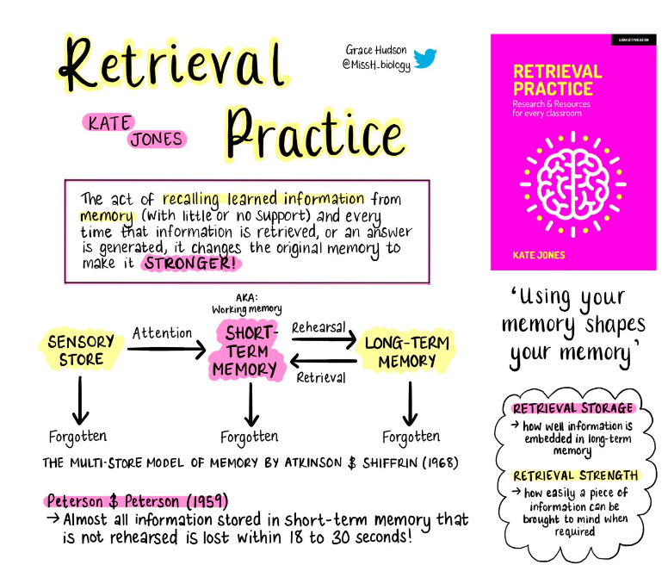
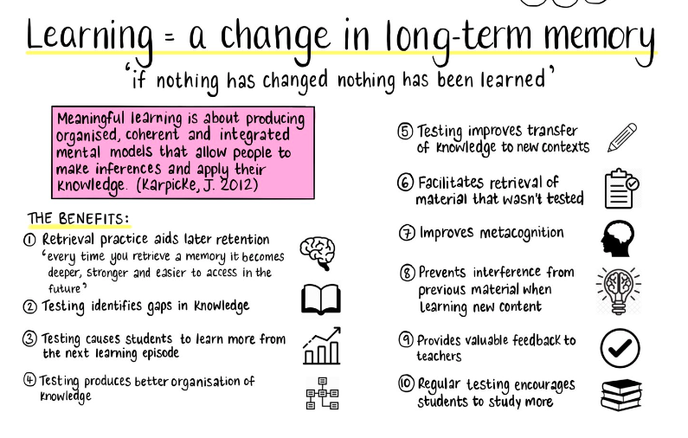
Handout 7
https://lovetoteach87.com/2020/09/09/a-collection-of-retrieval-practice-research-and-resources/

