Learning Progression Cognitive Verbs: Analogise
Analogise: When we analogise, we make a comparison of (something) with something else to develop understanding.
If you can analogise you can make a comparison between unlike things. The highest order thinking when analogising is done by comparing two abstract concepts. An interesting reflection question is to ask, “are the ideas surface features or deep relations?” with regard to what concepts the student has chosen to analogise.
Abstract and Concrete
Analogies can be made between:
- Two concrete objects (table and water slide). How is a table like a waterslide?
- An abstract idea (freedom) and a concrete object (animal). How is freedom like an animal of your choice?
- Two abstract ideas (intelligence and creativity). How is intelligence like creativity?
Related Key Words: similar, compare, liken, equate, link
Graphic Organisers: Hot SOLO Analogy Map (Hook 2004); Metaphor map (Thinkdrive 2019); Unlocking analogies (Faber 2018:152)
Sentence starter: Freedom is like a animal of your choice because……….
Analogise
5 | I can make a comparison in the format of “A is like B because…” to demonstrate my understanding of the concept/thing.
4 | I can recognise significance features that both concepts/things have in common.
3 | I can find a second concept/thing about which I know.
2 | I can recognise its significant features.
1 | I can select a concept/thing that I want to understand better
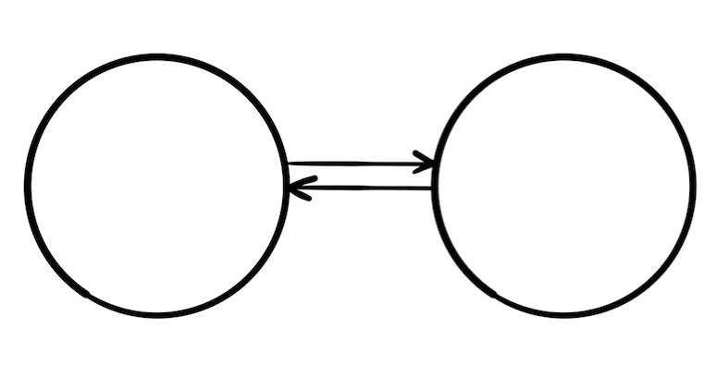

References:
Faber, S. (2018). How to teach academic vocabulary, Melbourne; Hawker Brownlow Education.
Hook, P. (2004). “Hot SOLO Analogy Map” in HookED.
http://pamhook.com/mediawiki/images/1/1e/HOT_Analogy_Template_2010.pdf
Thinkdrive, (2019) Queensland: ITC Publications
https://app.itcthinkdrive.com.au/understand/explain/metaphor
Harrison & Treagust RESEARCH GATE, 2006, Teaching and Learning with Analogies https://www.researchgate.net/publication/226440705_Teaching_and_Learning_with_Analogies
J. Farrall, AISSA & A. Pegler, Dara School, 2020.

