Six Hat Review of Science of Learning 2022 (using De Bono's Six Hat model).
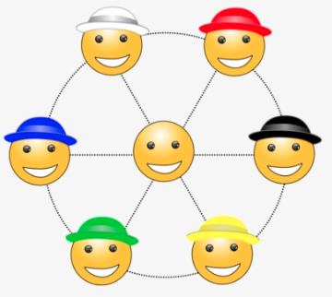
https://www.nicepng.com/ourpic/u2w7e6i1o0a9q8r5_six-thinking-hats-thought-smiley-computer-icons-six/

Questions/Instructions
- Describe briefly, 3-5 important take-a-ways for you from the SOL course
- List the advantages of the SOL course.
- List the drawbacks of the SOL course.
- Describe your feelings about the SOL course.
- In what ways could the SOL course be improved?
- Assess your progress as a learner and teacher of SOL. In what ways did you make progress? What areas/skills need further work?
- Further thoughts, questions or ideas?
© J. Farrall, November 2022

