SOL KEY TERMS | SOL TEACHER FRIENDLY RESEARCHERS & PRINCIPLES
Cognitive Load  Cognitive Load Theory:  Intrinsic  Extrinsic  Germane  Working Memory  Long-term memory  Schema  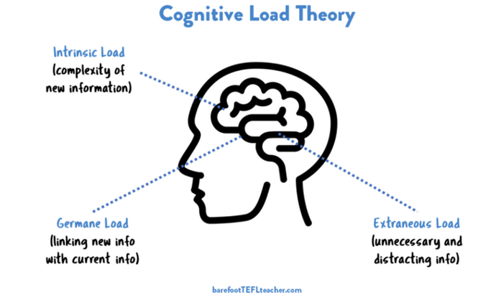 | Pooja Agarwal  Oliver Caviglioli  Jared Cooney Horvath  Kate Jones  Barack Rosenshine  Becky Sayers  Tom Sherrington  John Sweller  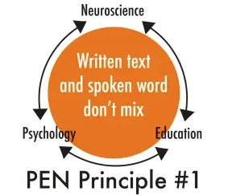  Micro-projects  PEN Principles  Pre-teaching  Rosenshine’s Principles  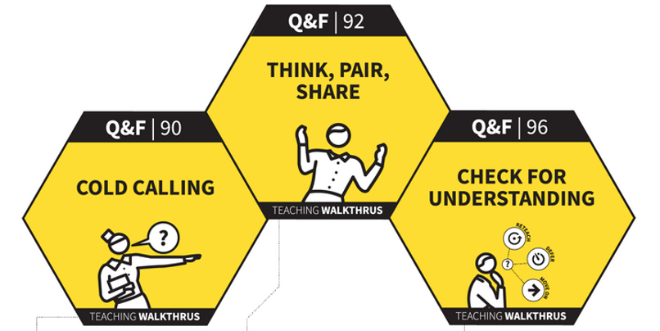  Walk Thru’s 1, 2 & 3
SOL STRATEGIES | SOL RESOURCES
Knowledge Organiser: Science of Learning  Elaborative Interrogation/Questioning  Dual Coding  Feedback  Interleaving  Low stakes testing  Knowledge Organiser  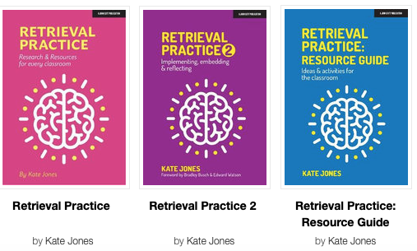  Managing Cognitive Load  Modelling/Examples  Retrieval practice  Self-explanation  Spaced practice  Related Concepts:  - Disciplinary Literacy  - Memory: Short and long-term  - Metacognition | BLOGS  Inner Drive: https://www.innerdrive.co.uk  Teacherhead (Sherrington) https://teacherhead.com/  WEBSITES  NSW Government. (2022). Cognitive load theory in practice: Research that teachers really need to understand. Centre for Education Statistics and Evaluation.  https://education.nsw.gov.au/about-us/educational-data/cese/publications/literature-reviews/cognitive-load-theory  PEN Principles  https://www.slrc.org.au/resources/pen-principles/  (J.E. Farrall 2022)
HO 1: Science of Learning: Knowledge Organiser.

