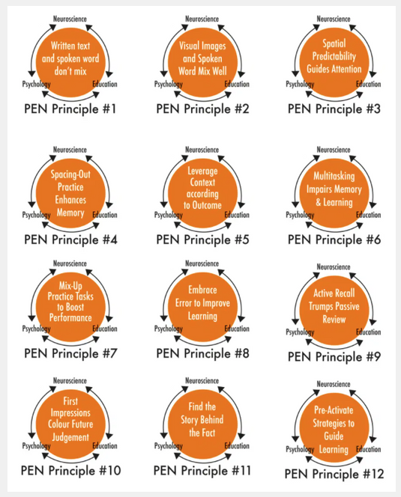

Handout 1: Pen Principles
Science of Learning Resource Centre. (2022). PEN Principles.
https://www.slrc.org.au/resources/pen-principles/

