Cognitive Verb Progression: Generalise
Definition:
Generalisations are patterns that are formed based on the big idea that is extrapolated from specific instances. (Bellanca 2012:174)

Related Key Words: universalise, hypothesise,

Graphic Organisers:
https://www.teacherspayteachers.com/Product/Making-Generalizations-Graphic-Organizer-635156

https://www.teacherspayteachers.com/Product/Making-Generalizations-Graphic-Organizer-Chart-Basic-Plus-Answers-58641

1. Generalise: Generalise means seeing a pattern in a relationship of a certain context and applying it to all.

Step 5 | I can apply the generalisation or the pattern in a variety of contexts
Step 4 | I can formulate a relationship from the pattern which can be applied to all
Step 3 | I can identify the pattern and use it to explain the context
Step 2 | I can see some meaning in the pattern
Step 1 | I can recognise a pattern that is emerging
Heritage College, 2019

2. Generalise: A statement that is true of all the examples of a concept.

Step 5 | I can justify the rule by referencing examples
Step 4 | I can state the connection between the feature and the concept as a rule
Step 3 | I can identify al least one feature common to all examples
Step 2 | I can locate examples of the concept
Step 1 | I can choose a concept to explore
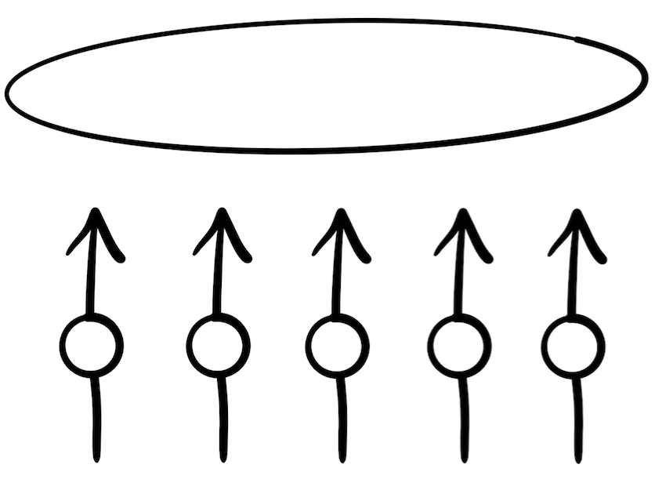

Reference:
Bellanca, J., Fogarty, R., Pete, B. (2012). How to teach thinking skills within the Australian Curriculum, Melbourne: Hawker Brownlow Education.

Heritage College 2019, J. Farrall, AISSA & A. Pegler, Dara School, 2020.

